Protocol for Monitoring Aquatic Invertebrates at Ozark National Scenic Riverways, Missouri, and Buffalo National River, Arkansas. Heartland I&M Network and Prairie Cluster Prototype Monitoring Program

SOP3: Sampling Invertebrates and Collecting Habitat Data

Version 2.0 (09/30/2016)

Revision History Log:
Previous Version # | Revision Date | Author | Changes Made | Reason for Change | New Version #
1.0 |  | Bowles | Substrate measurement changed to 3 pieces; field forms updated | 5 year review recommendations (DeBacker et al. 2012) | 2.0

This SOP describes field procedures for selecting riffles to sample within a stretch and the process for randomly selecting sample points within a riffle. The SOP further explains procedures for collecting and processing invertebrate samples in streams, and for collecting associated habitat data. Appropriate QA/QC requirements are highlighted within the procedure descriptions.

I. Riffle Selection within a Stretch

1. The sample unit is a ‘stretch’ of contiguous river as defined in the protocol narrative. Sampling and habitat analysis will be restricted to a section of this stretch.

2. Locate the stretch of river to be sampled:

  - Use GPS to find the lower geographic boundary of the stretch (beginning and ending points of stretches often correspond to tributary confluences which may help in locating the lower boundary in the field). For instructions on using the GPS, refer to the GPS SOP located at:
http://www1.nature.nps.gov/im/units/htln/data_management/data_management.htm
  - Locate the first riffle above the lower geographic boundary.
  - The area that will be sampled includes the next 3 riffles located in consecutive order upstream of the first riffle located above the lower boundary of the stretch as shown in Figure 1.

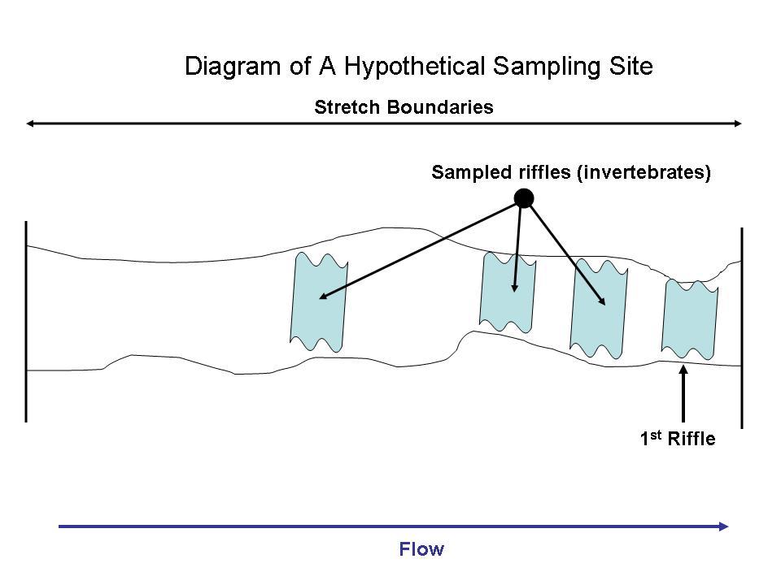
Figure 1. Diagram of riffle location within a stretch.

- Site names will be designated by the first four characters of the river name (BUFF, CURR, JACK), Mainstem (M) or Tributary (T), and the site/tributary number. Mainstem sites and tributaries will be labeled in successive order from upstream to downstream. Example: JACKM03 is the 3rd mainstem site on the Jacks Fork River. CURRT10 is the 10th tributary sampled in the Current River Basin. Sample site codes and GPS coordinates can be found in Appendix B of this protocol.

II. Collecting Benthic Samples and Associated Habitat Data

Procedure:

1. Prior to collecting benthic samples and taking habitat measurements, always complete data sheet information for site name (e.g., CURRM03), date and time of survey, sample season, and initials of personnel who collect the samples. Note: It is important to record the sample season as the physical year sampling began. Given sampling occurs at the end of the physical year in the winter, many times weather may cause sampling to go into next physical year (e.g., sampling may start in December 2015, but end in January 2016; therefore, the sample season would be 2015). This is important to ensure accuracy for data entry and analysis.

- Measure CORE 5 water quality variables using the procedures described in SOP#6.

3. Avoid walking in the riffle.

4. Collect three benthic samples per riffle. Benthic invertebrate samples will always be taken in an upstream direction. Individual benthic samples from riffles will be collected using the following a priori randomization procedure:

a) The sampling area is divided into three equal portions based on the measured length of the riffle as shown in Figure 2. First and foremost, the effective sampling area of the riffle will be based on safety of personnel, accessibility, and other pertinent factors determined by the investigators’ best judgment at the time of sampling. The upper and lower riffle boundaries generally will be based on a visual assessment of gradient, velocity, and substrate characteristics. However, care should be used to avoid including the deeper, downstream portion of the riffle as it transitions in deeper run habitat with more of v-shaped channel.

b) Collect individual benthic samples starting at river left (1/4 point), then alternating to the middle, and finally the right (3/4 point). Samples will be collected at the approximate midpoint of each portion. Indicate sampling sequence on the data sheet (L, M, or R). Approximate position of the samples is shown in Figure 2. The location of the sample may be modified if depth, velocity or other factors do not permit access to that portion of the channel.

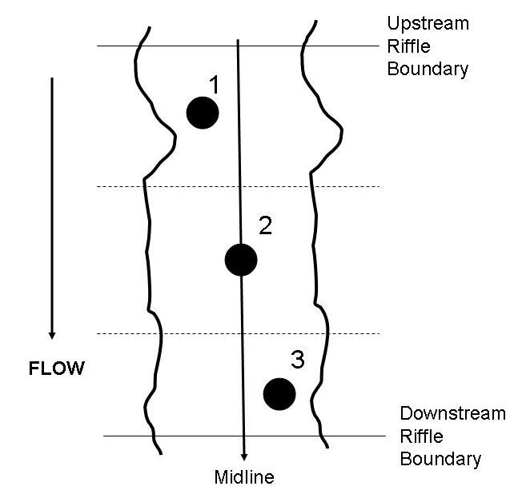

Figure 2. Diagram of sample locations within a riffle.

Note: Sample sequence should be altered only if the original starting point presents danger to the collector or if it is not accessible. Some riffles, especially those in the lower Buffalo River, may be wider than long and, in these instances, samples can be taken from left to right in equally spaced increments.

c) Samples will be collected with a Slack Surber sampler (analogous to the EPA-style rectangular benthic net) (~500 micron mesh) fitted with a sampling area guide (0.5 x 0.5 m² rectangle of PVC pipe placed immediately in front of the net) to delineate the approximate sampling area of 0.25 m² (Figure 3). Place the collection net and sample frame firmly against the stream substrate so that the opening is oriented directly into the stream current.

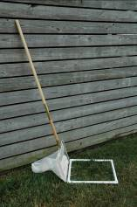

Figure 3. Invertebrate sampling net with sampling frame attached.

5. For each benthic sample, record habitat measurements based on visual estimates from within the sample frame on the habitat data form. Percentage categories are: 0= none (0%), 1= sparse (<10%), 2= moderate (10-40%), 3= heavy (40-75%), 4= very heavy (>75).

  - percent embeddedness of the substrate (e.g., bedrock & hardpan clay = 0% embeddedness; sand, clay, silt = 100% embededdness)
  - percent vegetation
  - percent periphyton
  - percent filamentous algae

6. Record dominant substrate size based on a visual estimate of three randomly selected pieces of substrate within the sampling net frame (Figure 4) using the Wentworth Scale (Table 1). A Wentworth scale category field sheet (provided at end of this SOP) is used for rapid measurement of substrate in the field (Figure 5). Record the corresponding substrate code on the data sheet.

Note: This technique is used to assess the dominant substrate in the sample area. It is not intended to fully characterize the substrate profile of the stream bottom.

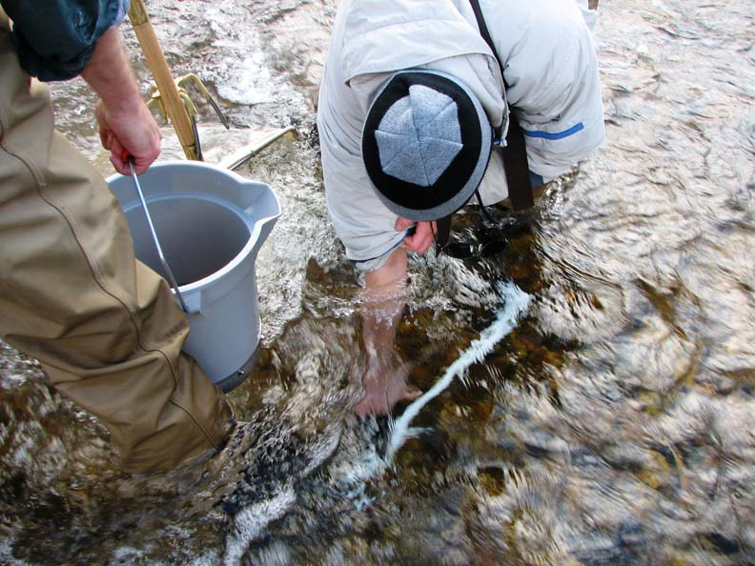

Figure 4. Collecting substrate from within the sampling frame.

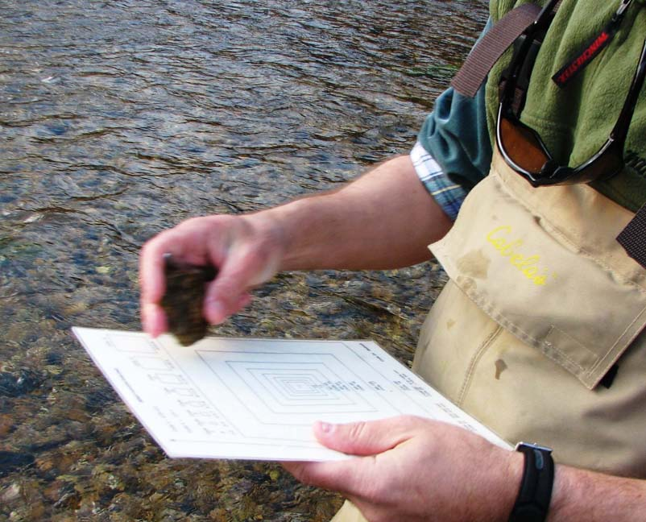

Figure 5. Measuring substrate with the field sheet.

- Average velocity (meters/second) and depth (centimeters) are measured concurrently at each sample point and immediately in front of the sample frame. Depth and velocity can be measured by a third team member while the other two members collect the benthic sample described in step 8 below. Measurements are done using a current meter attached to a top-setting wading rod. The rod allows for quick and easy measurements of depth with incremental markings and an adjustable arm which places the current meter at the proper depth for measuring velocity (60% of the depth from the surface of the water). Record velocity in meters per second and increments on the wading rod in centimeters. Greater detail regarding use of the velocity meter and wading rod are provided in SOP#5 “Measuring Stream Discharge.”

Table 1. Substrate size classes to be used for characterizing substrate based on the Wentworth Scale.

Size Code | Particle Diameter Range (mm) | Category
1 | <0.062 | Silt/clay
2 | 0.062-0.125 | Very fine sand
3 | 0.125-0.25 | Fine sand
4 | 0.25-0.50 | Medium sand
5 | 0.50-1 | Course sand
6 | 1-2 | Coarse sand
7 | 2-4 | Fine gravel
8 | 4-5.7 | Medium gravel
9 | 5.7-8 | Medium gravel
10 | 8-11.3 | Coarse gravel
11 | 11.3-16 | Coarse gravel
12 | 16-22.6 | Small pebble
13 | 22.6-32 | Small pebble
14 | 32-45 | Large pebble
15 | 45-64 | Large pebble
16 | 64-90 | Small cobble
17 | 90-128 | Small cobble
18 | 128-180 | Large cobble
19 | 180-256 | Large cobble
20 | 256-362 | Boulder
21 | 362-512 | Boulder
22 | 512-1024 | Boulder
23 | >1024 | Boulder
24 | Bedrock | Bedrock

8. Benthic sample collection

a. While one team member holds the net firmly against the stream bottom facing the current, a second team member then uses a garden cultivation tool to agitate the entire area within the net sample frame for a timed period of 2 minutes (Figure 6). At the end of 2 minutes the net can be lifted from the stream bottom, but with sufficient caution so as not to spill the sample.

b. Remove any large debris or rocks from the net and inspect for attached organisms. Scrub individual substrate pieces with a scrub brush to remove attached invertebrates as needed. These pieces can be discarded after any invertebrates have been removed. Pour and rinse the contents of the net into a wash bucket with a 500µm mesh sieve and rinse the sample by swirling the bucket in water using care not to submerge the bucket (Figure 6). Continue this process until all the fine silt and other sediments have been washed from the sample. Remove the sample contents from the wash bucket and place them in the sample container. Inspect the net, bucket, and sieve for any remaining organisms and carefully place them in the sample container (Figure 6). Excess water in the sample container can be drained into the sieve and inspected for organisms so that the preservative is not overly diluted.

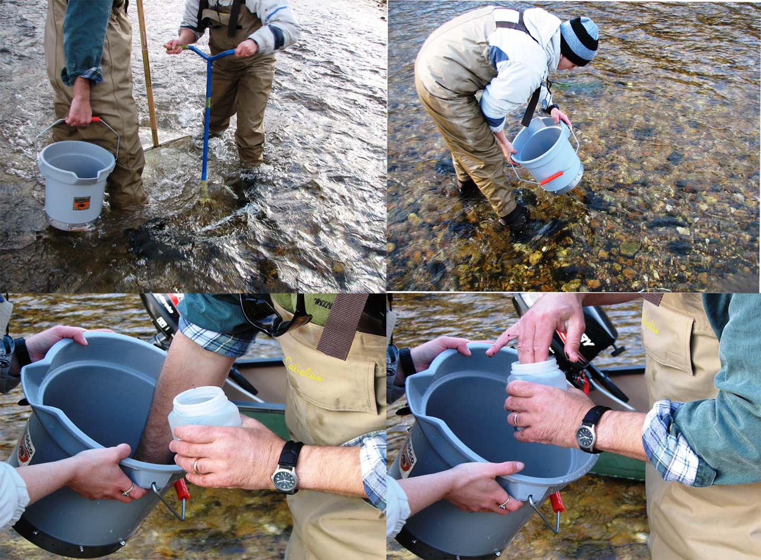

Figure 6. Placement of net on stream bottom and agitating substrate with garden tool (top left), washing the fine sediments from the sample using the wash bucket (top right) and transferring sample from wash bucket to sample container (bottom). Note that sample container is always held over wash bucket to ensure that sample is not accidentally spilled.

c. Once all organisms have been removed from the net, fill the jar with preservative (95% ethyl alcohol), ensure that the container is properly labeled, and tightly close the lid. Sample debris must be completely covered by preservative. Example sample labels are provided at the end of this SOP. Labels must be written in waterproof ink on 100% cotton (ragbond) paper.

d. Repeat this procedure for each discrete sample. Prior to leaving the site, recheck the samples to ensure they have been properly labeled and tightly closed, and ensure data sheets are properly completed.
10. Record any necessary notes about the collection site, mollusks left in place, or specific samples.
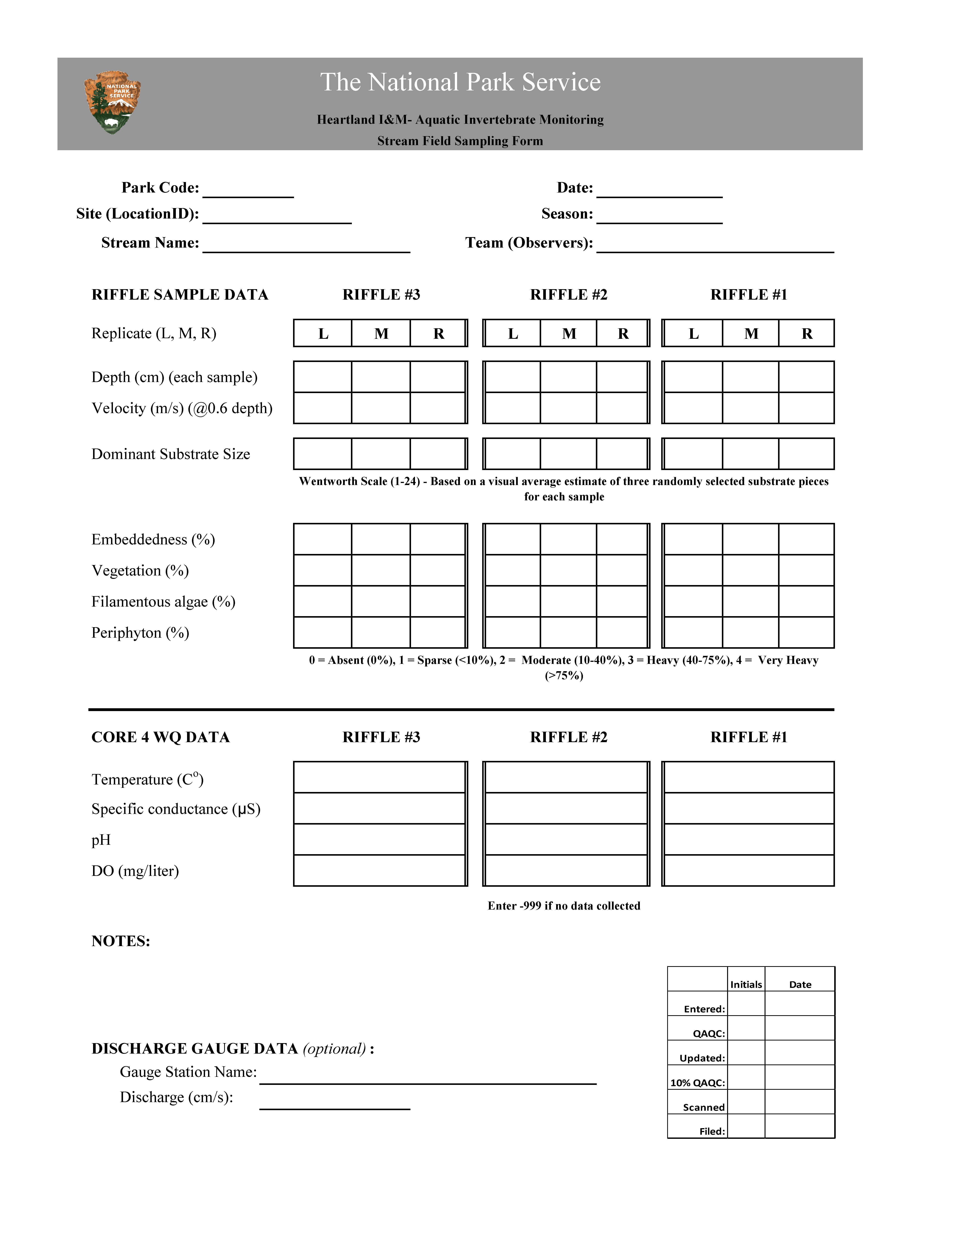
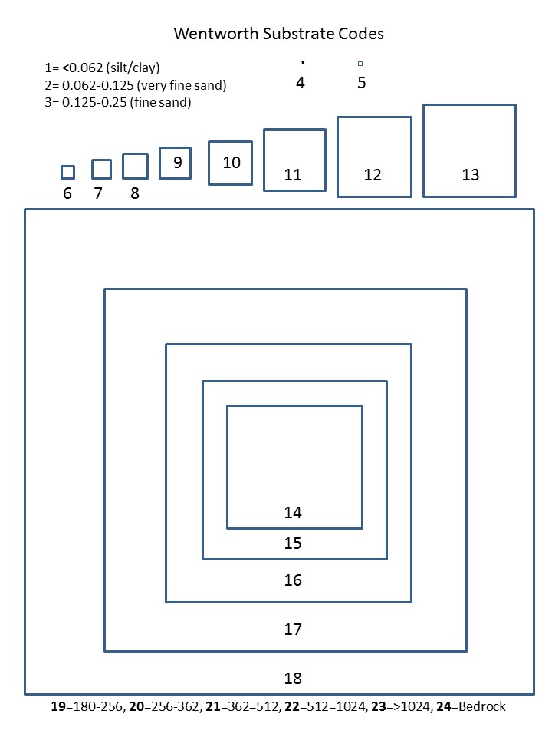


- Reference

Carter, R.W., and J. Davidian. 1969. General procedure for gaging streams. Book 3, Chapter A6 of Techniques of water-resources investigations of the United States Geological Survey. United States Government Printing Office, Washington, DC.

